Comparing Hydrologic/Hydraulic Modeling Techniques used by Regional Flood Control Districts for Drainage Design in Arizona
Final Report
June 2023

Prepared by
Yoganand Korgaonkar
Assistant Professor of Practice
School of Geography, Development & Environment
University of Arizona

Acknowledgements
This project was a direct result of funding from The Nature Conservancy.
Special thanks to the efforts of Holly Richter, Kimberly Schonek (The Nature Conservancy), Juliet McKenna (Montgomary & Associates) in engaging and conducting interviews with the stakeholders that helped in getting this project started.
Thanks to the key stakeholders from the regional flood control districts of Cochise County, Maricopa County, Pima County, Pinal County and Yavapai County, for their participation in the surveys and meetings.
I express my gratitude to Dave Goodrich (USDA-ARS) and Phil Guertin (University of Arizona) for the support and advice throughout the course of this project.

Table of Contents
Executive Summary 4
Introduction 5
Background 5
Objectives 6
Qualitative Comparison 7
Software Overview 7
AGWA Urban Tool 7
EPA SWMM 7
HEC-HMS 8
Watershed Representation 8
Modeling Options 9
Meteorology Options 11
Simulation Results 11
Case Study 13
Study Area 13
Model Setup 14
AGWA Urban tool 14
SWMM 16
HEC-HMS 17
Comparison of Results 19
Conclusion 24
References 26

List of Tables
Table 1: Summary of Runoff depth and Peak Flow at the watershed outlet for predevelopment and postdevelopment scenarios. 21
Table 2: Water balance comparison of Parcel ID 9 for predevelopment and postdevelopment scenarios. 23
List of Figures
Figure 1: Stormwater Volume as percentage of rainfall at different watershed scales. Figure created by Dr. Evan Canfield. 5
Figure 2: KINEROS2 urban element that can model pervious and impervious areas within a modeling element. 9
Figure 3: Conceptual view of surface runoff modeling in SWMM. d= depth of water, ds = maximum depression storage. Figure obtained from SWMM 5.0 user guide). 10
Figure 4:Typical representation of watershed runoff. Figure obtained from HEC-HMS technical manual. 11
Figure 5: The La Terraza subdivision in Sierra Vista, AZ. 13
Figure 6: Location of the NOAA Atlas 14 Precipitation station in Sierra Vista, AZ. Map obtained from the NOAA Atlas 14 precipitation frequency estimates website: https://hdsc.nws.noaa.gov/pfds/pfds_map_cont.html?bkmrk=az 14
Figure 7: La Terraza subdivision representation in the AGWA Urban tool. Blue lines indicate the flow path of runoff. 15
Figure 8: La Terraza subdivision representation in EPA SWMM. Subcatchments are prefixed with "ID", junctions with "J" and conduits or links are prefixed with "C". 17
Figure 9: La Terraza subdivision representation as a basin model in HEC-HMS. 18
Figure 10: AGWA Urban tool model execution summary for the postdevelopment scenario. 19
Figure 11: SWMM status report for the postdevelopment scenario simulation. 20
Figure 12: HEC-HMS global summary for the postdevelopment scenario. 21
Figure 13: Comparison of hydrographs for predevelopment and postdevelopment scenarios for all models. 22

Executive Summary
Urbanization increases impervious areas and decreases infiltration that results in excess surface runoff, also known as urban enhanced runoff. Urban enhanced runoff provides the opportunity to utilize this excess stormwater for multiple benefits by means of green infrastructure or low impact development or recharge basins that can significantly contribute to groundwater recharge. In Arizona, Regional Flood Control Districts are responsible for drainage design to mitigate flood risk due to excess runoff. These districts utilize various hydrological models to simulate watershed hydrology to estimate peak discharges that serve as a primary input for drainage design.
Two models, Hydrological Engineering Center’s Hydrologic Modeling System (HEC-HMS) and the Environmental Protection Agency’s (EPA) Storm Water Management Model (SWMM) were identified as models used by the Regional Flood Control District to model hydrology and hydraulics for drainage design. The goal of this study was to compare these models with the Automated Geospatial Watershed Assessment (AGWA) Urban tool to assess their capabilities and ease-of-use and to model urban enhanced runoff for a small urban watershed. This project conducts a qualitative comparison and summarizes the functionality of all three models and includes a case study that compares the process of preparing and executing a predevelopment and postdevelopment simulation to quantify urban enhanced runoff for the La Terraza subdivision in Sierra Vista, Arizona. The scope of case study is limited to the comparison of a simple setup of AGWA Urban tool, EPA-SWMM, and HEC-HMS without any calibration or validation.
The AGWA Urban tool is embedded within ESRI ArcMap, a geographic information system (GIS) software that requires a paid license. On the other hand, SWMM and HEC-HMS are both standalone software that are free to download and use. HEC-HMS offers limited GIS capabilities, whereas SWMM has no GIS integration. The AGWA Urban tool and HEC-HMS can model urban areas using kinematic wave equations for overland flow. SWMM uses a non-linear reservoir routing method along with Manning’s equation to model overland flow, but its strength is in flow routing for conduits.
The AGWA Urban tool, EPA SWMM and HEC-HMS are all capable of modeling urban areas at various scales to estimate peak discharges that can be used to design drainage practices for flood mitigation and to estimate urban enhanced runoff that can help in planning creative implementations, such as green stormwater infrastructure or recharge facilities to manage stormwater runoff. Despite the similarity in capabilities, the decision to use a particular model may be influenced by several factors not limited to watershed characteristics or familiarity of the model by the modeler.

Introduction

Background
New urban development modifies existing natural hydrology by replacing pervious surfaces with impervious surfaces such as roofs, driveways, sidewalks, and roads. The increase in impervious surfaces and the decrease in natural vegetation reduce the infiltration of water into the soil and the evapotranspiration of water via plants and trees and increase the volume of surface runoff (Shuster et al., 2005). The excess surface runoff, also known as urban enhanced runoff, generated by impervious surfaces causes high peak flows that increase the risk of flooding. Urban enhanced runoff contributes to the flood risk at the local scale, in the neighborhood, as well as downstream in the watershed. In the semi-arid region of Arizona, the volume of runoff from an urban area is directly related to the scale of the watershed (Figure 1; City of Tucson, Pima County, 2009). The largest percentage of runoff generated from rainfall is at the rooftop scale, followed by the lot scale.
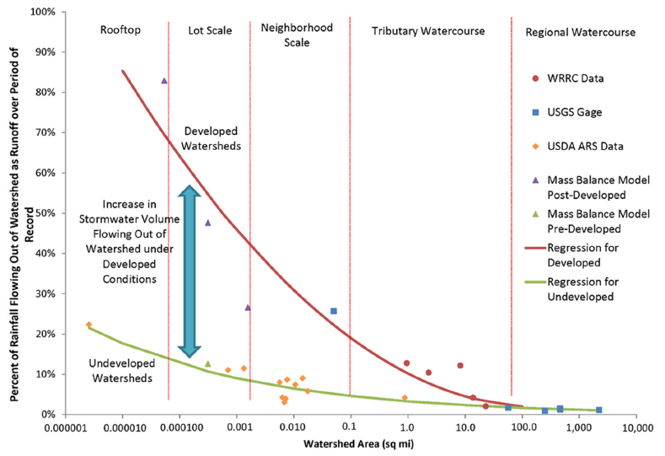
Figure 1: Stormwater Volume as percentage of rainfall at different watershed scales. Figure created by Dr. Evan Canfield.
Traditionally, grey infrastructure, such as curb-and-gutter systems, hardened channels, and sub-surface drainage networks, was used to promote rapid movement of water from the landscape to the nearest wash, river, or water body, to mitigate flooding. Regional Flood Control Districts created by counties are involved in various floodplain management practices that aim to reduce the risk of damage caused by flooding. These districts utilize various hydrologic and hydraulic modeling techniques and software to quantify flooding risks and enable drainage design.
More recently, green infrastructure practices such as rain gardens, retention basins, rainwater cisterns, curb cuts, and permeable pavements have been used to capture runoff at the road, lot, and neighborhood scales (Dietz, 2007; Hopton et al., 2015). The captured water serves the purpose of augmenting the local water supply in the form of water available for irrigation or non-potable household uses in addition to reducing the risk of flooding. Various urban hydrological models have been used successfully to model urban hydrology and green infrastructure (Elliott and Trowsdale, 2007; Zoppou, 2001).
Stormwater management can result in multiple co-benefits from ecosystem services offered by green infrastructure practices to downstream groundwater recharge. Quantification of urban enhanced runoff is necessary before any planning or implementation exercise.

Objectives
This project aims to understand if the hydrologic and hydraulic models and software used by Regional Flood Control Districts provide functionality to calculate volume of water quantified as urban enhanced runoff in addition to peak flows in an urban watershed. The goal would be to compare these methodologies to the Automated Geospatial Watershed Assessment (AGWA) Urban tool, a user-friendly, Geographic Information Systems (GIS) based tool that uses a physically based Kinematic Runoff and Erosion (KINEROS2) model. This project seeks to understand if the AGWA Urban tool can be a viable alternative to current models and software used by Regional Flood Control Districts in Arizona.
Hydrologic and hydraulic models of interest were identified based on interviews and meetings conducted by Juliet McKenna (Montgomery & Associates) and Holly Richter (formerly, The Nature Conservancy) with various members of the Regional Flood Control Districts across the state of Arizona. These interviews identified the Hydrological Engineering Center’s Hydrologic Modeling System (HEC-HMS) and the Environmental Protection Agency’s Storm Water Management Model (SWMM) as two models that are commonly used.
This project conducts a qualitative comparison and summarizes the functionality of all three models and includes a case study that compares the process of preparing and executing a predevelopment and post development simulation in these models to quantify urban enhanced runoff on the La Terraza subdivision in Sierra Vista, Arizona. The scope of this project is limited to the comparison of a simple setup of AGWA Urban tool, EPA-SWMM, and HEC-HMS without any calibration or validation and comparing runoff volumes and hydrographs.

Qualitative Comparison

Software Overview

AGWA Urban Tool
The KINEROS2 model, developed by the USDA-ARS, is a spatially distributed, physically based, event-driven model that simulates runoff and erosion for small watersheds (Smith et al., 1995; Goodrich et al., 2012; https://www.tucson.ars.ag.gov/kineros/). The KINEROS2 model uses text files to serve as the medium for inputs and outputs. The AGWA Urban tool was created to utilize the capabilities of the KINEROS2 model to model urban hydrology and GI practices by representing each parcel in the urban landscape as a modeling element using GIS (Korgaonkar et al., 2018; Miller et al., 2007; https://www.tucson.ars.ag.gov/agwa/). The AGWA Urban tool has been used in case studies in Sierra Vista, AZ (Korgaonkar et al., 2018) as well as Tucson, AZ (Korgaonkar et al., 2021), firstly to represent the current conditions in an urban setting and secondly, to model various scenarios implementing GI practices in these watersheds. Results from these studies are useful to understand the flow of water in urban watersheds and the impact of GI in mitigating floods and augmenting local water supply.
The AGWA Urban tool is available on request as an add-in for the ESRI ArcMap software (https://www.esri.com/en-us/arcgis/products/arcgis-desktop/overview). ESRI ArcMap requires a paid license that several local, state, and federal agencies may already have access to (https://www.esri.com/en-us/industries/enterprise-agreement/government).
The AGWA Urban tool within ArcMap provides a windows-based interface that utilizes GIS tools available in ArcMap to process and extract parameters from readily available spatial datasets such as parcels, streets, and soils. Users follow a step-by-step methodology to set up and execute a simulation as detailed in Korgaonkar et al (2018). Each step involves selecting various options and parameters from drop-down menus and entering information in text boxes. Spatially extracted data, along with user input parameters are then processed to create text files that are required by KINEROS2. Results can be viewed in ArcMap as spatial results or results text files can be accessed outside of the software for analysis.

EPA SWMM
EPA SWMM (https://www.epa.gov/water-research/storm-water-management-model-swmm; Rossman, 2010) is maintained by the US EPA and was developed in a joint effort with CDM Smith Inc. SWMM is a Windows-based program that is open source and free to use. It features a graphical user interface with point-and-click functionality that enables the creation of models to represent hydrology as well as hydraulics typically seen in urban environments. For bulk edits or for large number of modeling elements, SWMM input files may be accessed, viewed, and modified in a text editor. SWMM has capability for hydraulic modeling of drainage networks, open and closed conduits and natural channels, pumps, weirs, and various flow regimes. Additionally, SWMM can model various hydrologic processes such as evaporation, snow accumulation and melting, interception, reservoir routing along with surface water routing. It can also be used to estimate pollutant loads as well as model green infrastructure practices as low impact development controls (Niaza et al., 2017; Rosa et al., 2015).

HEC-HMS
HEC-HMS (https://www.hec.usace.army.mil/software/hec-hms/), was developed by the US Army Corps of Engineers and is one of the most popular software for hydrologic modeling and flood risk analysis (Forsee and Ahamd, 2011; Natarajan and Radhakrishnan, 2019; Sahu et al., 2023). HEC-HMS is a standalone software that features a graphical user interface and is free to use. HEC-HMS enables the representation and simulation of hydrological processes of dendritic watershed systems. The software includes GIS integration that currently allows the delineation of basins and channels from elevation datasets, and estimation of parameters from grid datasets. HEC-HMS also features a tabular interface that allows the preparation and modification of input parameters for modeling elements.

Watershed Representation
The KINEROS2 model uses cascading planes and channels to represent a watershed. It uses curvilinear or planar rectangular elements to represent hillslopes. Open channels are represented using trapezoids and may have a compound cross section with overbank representations. Circular conduits without pressurized flows can also be represented in the model. In addition to these, KINEROS2 also offers representation of urban areas using the urban element, an injection element to represent inflows, adder and divertor elements to represent confluences and diversions, as well as detention ponds. The AGWA Urban tool utilizes the KINEROS2 urban element to represent parcels in urban areas.
SWMM represents watersheds using a network of subcatchments, links and nodes. Subcatchments represent rectangular hydrologic units of land that may include pervious and impervious areas. Links are conduits, pumps, and regulators (weirs, orifices, outlets) that represent the conveyance of water between a pair of nodes. Nodes are used to represent points in the conveyance system where subcatchments and links can be connected to and can be used to represent storage units (catch basins, ponds, lakes) in the watershed.
HEC-HMS utilizes subbasins, reaches, and junctions to represent a dendritic watershed. Catchments can be represented using rectangular subbasin elements that have only one outflow. Reach elements are used to model rivers and streams and can be used to represent multiple inflows leading to a single outflow. Junction elements are used to represent confluences. In addition to the above elements, HEC-HMS also contains source elements to represent upstream boundary conditions, sink elements to represent the watershed outlet, diversion element to represent the withdrawal of water from a channel, and reservoir elements to represent dams and storage reservoirs.

Modeling Options
All three models are spatially distributed, physically based and offer discrete and continuous simulation options. HEC-HMS and SWMM offer multiple modeling options in terms of simulating infiltration, overland flow, and flow routing.
The KINEROS2 used within the AGWA Urban tool can model overland flow, channels, green infrastructure practices, non-pressurized pipe flow, pre- and post-fire burn scenarios, baseflow, impoundments and reservoirs. KINEROS2 uses the Parlange three-parameter model that utilizes Green and Ampt and Smith and Parlange models (Smith and Goodrich, 2000). KINEROS2 uses one-dimensional kinematic wave equations to provide discharge along a flow path. Channel flow is assumed to be unsteady and open channel and represented using the kinematic wave approximation. Channels can be simple or compound with a trapezoidal cross-section. The urban element in KINEROS2 can be used to represent individual impervious areas such as roofs (ICIs), driveways (DCPs) and street halves and pervious areas such as front (CPs) and yards (DCPs) for each parcel (Figure 2).
Figure 2: KINEROS2 urban element that can model pervious and impervious areas within a modeling element.
SWMM can model overland flow, groundwater, snowmelt, various LIDS, surface ponding, water quality, conduits, pumps, and flow regulation. SWMM offers three infiltration models: Horton, Green-Ampt, and Curve Number. The parameters required to simulate infiltration vary based on the selected infiltration model. SWMM uses non-linear reservoir routing and Manning’s equation to compute surface runoff that occurs when depth (d) of water exceeds the maximum depression storage (ds) after infiltration losses are calculated (Figure 3). In SWMM, steady flow routing, kinematic wave and dynamic wave are included as options for flow routing.
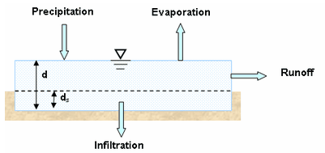
Figure 3: Conceptual view of surface runoff modeling in SWMM. d= depth of water, ds = maximum depression storage. Figure obtained from SWMM 5.0 user guide).
HEC-HMS can model overland flow, baseflow, channels and reaches, impoundments, reservoirs, and diversion structures (Figure 4). HEC-HMS offers different Loss methods to calculate infiltration based on whether the simulation is event-based or continuous. For event-based simulations, infiltration losses can be simulated using the following methods: Exponential, Green and Ampt, Gridded Green and Ampt, Initial and constant, SCS curve number, and Smith Parlange. For continuous simulations, the options include Deficit and constant, Gridded deficit and constant, Gridded soil moisture accounting, Layered Green and Ampt and soil moisture accounting. HEC-HMS calculates surface runoff using a Transform method. Nine different transform methods are available including various Unit Hydrograph methods, Kinematic Wave implementations (recommended for urban areas), Linear Quasi-distributed method, and a two-dimensional diffusion wave method. HEC-HMS has nine different routing methods for open channel flow that include kinematic wave, lag routing, lag and K routing, modified Puls routing, Muskingum routing, Muskingum-Cunge routing, Normal Depth routing, and Straddle Stagger routing. The Kinematic Wave Transform method conceptually uses two representative planes, one to represent pervious areas and the other to represent impervious areas. The composite runoff from these planes is directed to a subcollector representing gutters along streets. This runoff is then routed to a collector that can represent larger gutters or ditches. Finally, the runoff enters the channel element to represent the final step of a stormwater management system.
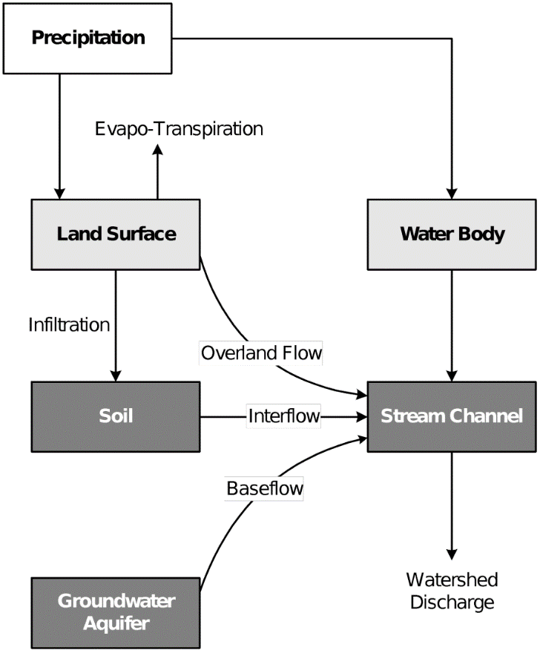
Figure 4:Typical representation of watershed runoff. Figure obtained from HEC-HMS technical manual.

Meteorology Options
All models require precipitation data for simulation of discrete events, and evapotranspiration data is required to model continuous events in SWMM and HEC-HMS. In addition to evapotranspiration, SWMM can also utilize wind speed, snowmelt, and areal depletion data in the form of time-series, or a climate file. HEC-HMS provides the option to include shortwave and longwave radiation data along with snowmelt. The AGWA Urban tool can consume precipitation data using NOAA Precipitation Frequency maps, user-defined depth, user-defined hyetograph, pre-defined design storms, and user-defined csv files. SWMM requires user-defined time-series data as precipitation input. HEC-HMS has the option to use frequency storm methods, HMR52, hypothetical storms, standard project storms, user-defined hyetographs, and gridded precipitation datasets.

Simulation Results
The AGWA Urban tool provides spatial visualization of runoff and infiltration volumes for individual parcels in GIS. The KINEROS2 model also creates text files with water balances for individual modeling elements as well as the entire watershed along with time-series outputs for precipitation, runoff volume and peak flows for individual modeling elements.
SWMM provides a simulation summary results for each subcatchment element that includes precipitation, runon, evaporation, infiltration, total runoff, and peak flows. Depth and inflow summaries can be viewed for node elements, and peak flows, spreads, velocities, and depths for conduits. Additionally, various graphs and tables can be generated for the above outputs for each modeling object from the simulation results. SWMM features a map that can animate results on the modeling objects based on the simulation time steps to provide a visual understanding of the simulation.
HEC-HMS creates a global summary for the basin model that includes the drainage area, peak discharge, time of peak and the volume for each hydrologic element. Summary and time-series tables are also available for individual modeling elements along with graphs of precipitation, potential evapotranspiration, canopy outputs, surface storage, soil infiltration and direct runoff.

Case Study
The goal of this case study is to understand the process behind setting up the SWMM and HEC-HMS models using data created by setting up the AGWA Urban tool to simulate a 100-year 2-hour event on predevelopment and post development conditions at the La Terraza subdivision in Sierra Vista, Arizona (Figure 5).
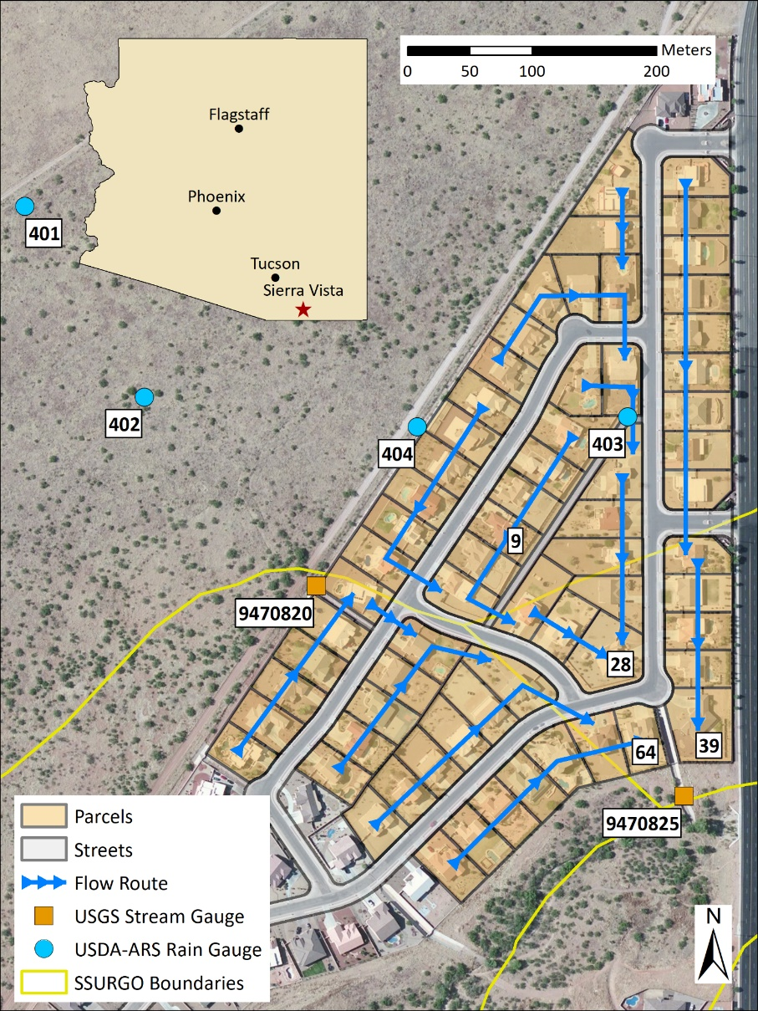
Figure 5: The La Terraza subdivision in Sierra Vista, AZ.

Study Area
The La Terraza subdivision is a 14-hectare residential subdivision located in the city of Sierra Vista in southeastern Arizona (Figure 5). It contains 66 residential lots with an average lot size of 1780 square meters, and an average roof area of 380 square meters. The subdivision drains to the southeast corner through a concrete conduit. The dimensions of the lots, and various input parameters were derived from previous studies by Kennedy et al. (2013) and Korgaonkar et al. (2018). Precipitation input for the purpose of this case study was obtained from NOAA Atlas 14 for the Sierra Vista station (ID 02-7880; Figure 2) with a recurrence interval of 100 years and a duration of 2 hours that amounted to a depth of 2.89 inches or 73.406 mm.
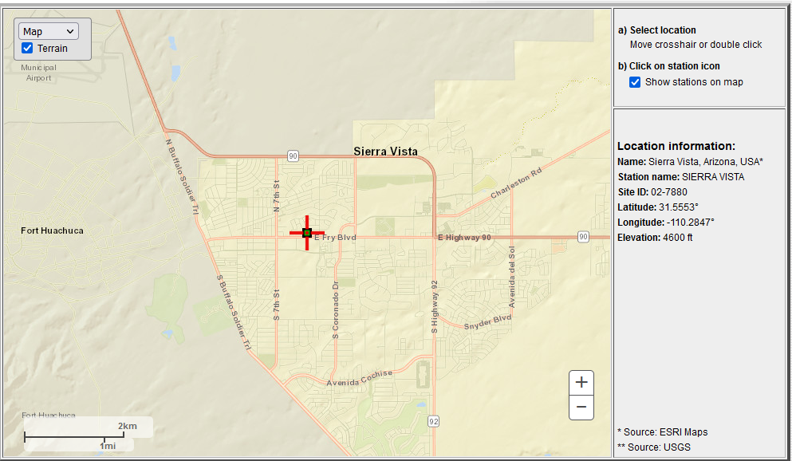
Figure 6: Location of the NOAA Atlas 14 Precipitation station in Sierra Vista, AZ. Map obtained from the NOAA Atlas 14 precipitation frequency estimates website: https://hdsc.nws.noaa.gov/pfds/pfds_map_cont.html?bkmrk=az

Model Setup

AGWA Urban tool
The parcels and streets datasets were first imported into ArcMap to set up the Urban geodatabase. The table for the parcels data included the width of each parcel adjoining the street calculated using GIS tools. This width determines the width of the rectangular urban element that models the parcel in KINEROS2. Overland stormwater flow paths were created by drawing lines using tools in ArcMap via the AGWA Urban Flow Routing step to complete the watershed representation (Figure 7) The watershed outlet is computed to be the confluence of parcels 28, 39 and 64.
Two parameterizations were created to represent predevelopment and postdevelopment scenarios. Element and land cover parameters were derived from Korgaonkar et al. (2018) and the SSURGO dataset and database was used to derive soils parameters for the watershed. To represent predevelopment conditions all impervious areas, such as roofs and driveways, on the parcels were converted to pervious areas, and parameters for impervious areas were modified to be the same as pervious areas. The street network remained unchanged for the predevelopment scenario.
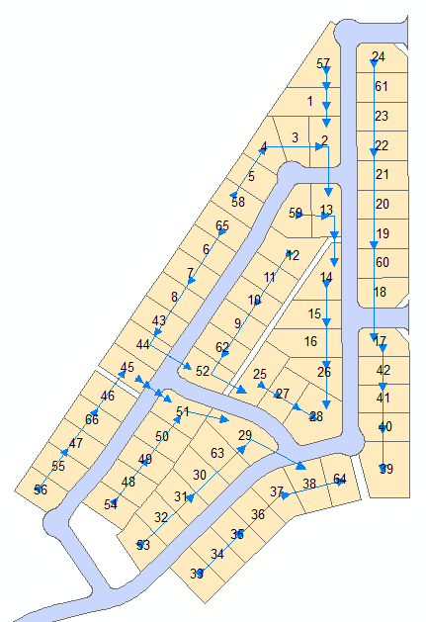
Figure 7: La Terraza subdivision representation in the AGWA Urban tool. Blue lines indicate the flow path of runoff.
Next, precipitation data was imported into the model by selecting the User-defined depth option as the storm source and providing the depth, duration, time steps for the 100-yr 2-hr event. The hyetograph shape was set as SCS Type II per this region and initial soil moisture conditions for the watershed was set to 0.2. After all the above inputs were prepared, the next step created the text files that are required for KINEROS2 to execute. These text files may be viewed outside of GIS and can be modified before model execution. The Urban KINEROS Execution step allowed for model execution for both scenarios and a command prompt window displayed the model execution with a summary of results for both.
Finally, results were imported and viewed as a map in ArcMap and exported as tables to be viewed and analyzed outside of the GIS software.

SWMM
To simulate predevelopment and postdevelopment scenarios, two different projects were created. The following steps were similar for both projects with changes in input parameters as stated below.
First, default values were set for subdivisions, nodes and links. All subcatchment labels were set to begin with “ID”, junctions to begin with the letter “J”, and conduits to begin with the letter “C”. Default roughness values for impervious areas was set to 0.011 to represent asphalt and concrete and set to 0.02 for pervious areas to represent graveled surface, typically representative of land cover in this region. Default values for impervious and pervious area depression storage was set to 0. The Modified Green and Ampt model was selected as the default infiltration model. The default conduit geometry was selected to be a Street and a new street section was created with road width to crown of 28 ft, curb height of 0.56 inches, and road roughness of 0.011 to represent asphalt streets.
The next step was to create subcatchments objects to represent each modeling element. SWMM does not have GIS linking capabilities. As a result, sixty-six subcatchments objects would have to be digitized in the Study Area Map window. To circumvent the manual digitizing of sixty-six parcels, coordinates of vertices for all sixty-six parcel polygons were exported using ArcMap, formatted, and placed in the appropriate location in the input file using a text editor. These parcels were available and visible as subcatchment objects on the map when the project was reopened in SWMM. Once the parcels were imported, junctions and conduits were drawn on the map and connected to the subcatchments to represent the flow path using the point-and-click interface. An outfall node was created to represent the watershed outlet. Finally, a rain gage object was added at a random location to store the precipitation information for the watershed (Figure 8).
Once the study area map is created, each object (subcatchment, junction or conduit) must be individually selected to enter manually enter parameters. To speed things up, the input file for this project was once again opened in a text editor and parameters were copied from tables created in the GIS interface of the AGWA Urban tool into the input file instead of using the SWMM user interface. The parameters were automatically filled and viewable for all objects in the user interface once the project was reloaded. To simulate the predevelopment scenario, percent impervious on all subcatchments was reduced to 0 and roughness was set to 0.02 to represent graveled surfaces instead of 0.011 (representing asphalt surfaces) as used for the postdevelopment scenario. The street network remained unchanged in the predevelopment scenario.
Next, a time series was created to represent the 100-year 2-hr precipitation data. Time value pairs were manually entered using the AGWA Urban tool generated precipitation file. This time series was then selected as the data source for the rain gage object.
Finally, simulation options that include dates and time steps were entered to complete the model setup. A reporting time-step of 5 minutes was selected in this case and the simulation was run to compute the results.
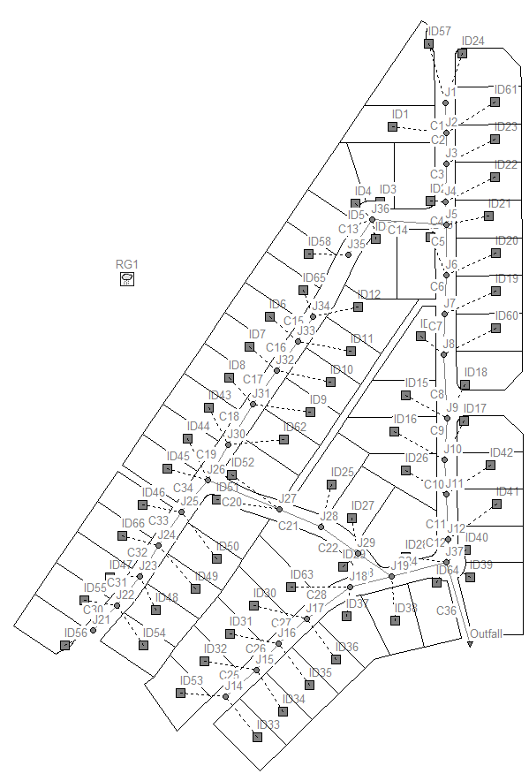
Figure 8: La Terraza subdivision representation in EPA SWMM. Subcatchments are prefixed with "ID", junctions with "J" and conduits or links are prefixed with "C".

HEC-HMS
HEC-HMS model set up begins with a basin model to represent the post development scenario and another basin model to represent the predevelopment scenario. The following methodology represents the postdevelopment scenario and the predevelopment scenario follows a similar setup process. The parcels dataset used in the AGWA Urban tool was imported using the built-in GIS functionality that allowed the import of georeferenced elements to create sixty-six subbasins. Downstream connections were manually created for each subbasin to create a flow path for the watershed. Four junctions were added to manage confluences in the flow path and a fifth junction, named “Outlet” was created to represent the watershed outlet (Figure 9).
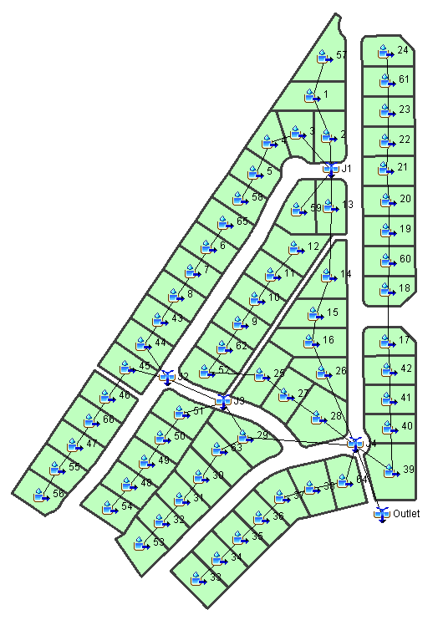
Figure 9: La Terraza subdivision representation as a basin model in HEC-HMS.
The Kinematic Wave method was selected as the Transform method for all components that creates two planes for each subbasin. Plane 1 was assumed to be the directly connected impervious area on the parcel, whereas Plane 2 was assumed to be the pervious area on the parcel. No collector or subcollector channels were used for this case study. However, a main channel component was utilized to represent street halves for each subbasin element. The parameters for the flow planes and the main channel were imported from tables generated by the AGWA Urban tool in ArcMap.
The Simple Canopy method was selected with 0% initial deficit for both planes, and 0 and 2mm maximum storage for Planes 1 and Planes 2, respectively. Next, the Simple Surface method was selected with 0% initial storage and 0mm maximum storage for all subbasins and planes. The Green and Ampt method was selected as the Loss method and the required parameters were again imported from AGWA Urban generated tables. The percent impervious for planes 1 was set to 100% to represent directly connected impervious areas and set to 0% for planes 2 to represent pervious areas. All other parameters remained the same for both planes.
For the predevelopment scenario, canopy maximum storage and roughness parameters were modified to reflect the parameters for pervious surfaces. Additionally, the percent area parameter in the Transform method for both planes was changed to be equal instead of the split between percent impervious and percent pervious used in the postdevelopment scenario. Finally, the percent impervious parameter for Planes 1 in the Loss method was modified to 0% to represent the lack of impervious area in the predevelopment scenario.
Next, a Meteorologic model was created to represent the 100-year 2-hr precipitation event using the Frequency Storm precipitation option. A Control Specification was then added to run the simulation for 12 hours in 5-minute intervals. To execute simulations, individual simulation runs were created using the Simulation Run Manager for the predevelopment and postdevelopment scenarios. Each of these simulation runs were then computed to prepare the results.

Comparison of Results
The AGWA Urban tool displayed a command prompt with a water balance summary for the entire watershed (Figure 10) upon model execution. KINEROS2 created output text files with detailed results that were imported into AGWA in the View results step. Once the results are imported, parcels were visualized to display runoff and infiltration volumes on the map. To view detailed water balances and hydrographs for each modeling element, text files were accessed outside of the GIS software and analyzed in a spreadsheet software.
Results from EPA SWMM are self-contained within the software. A status report was generated for each simulation that contains a continuity summary for surface runoff quantity and flow routing in conduits (Figure 11). Tabular summaries were also available for each modeling element, including subcatchments, nodes and conduits. In addition to tables, graphs can be created for each modeling element and corresponding output parameter.
Similarly, HEC-HMS generated a global summary for each of the scenario simulations. Each global summary included the peak discharge and volume for each hydrologic element in the model (Figure 12). In addition to the global summary, the simulation run also created graphs, summary tables, time-series tables for each hydrologic element.
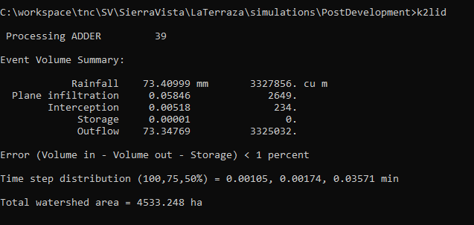
Figure 10: AGWA Urban tool model execution summary for the postdevelopment scenario.

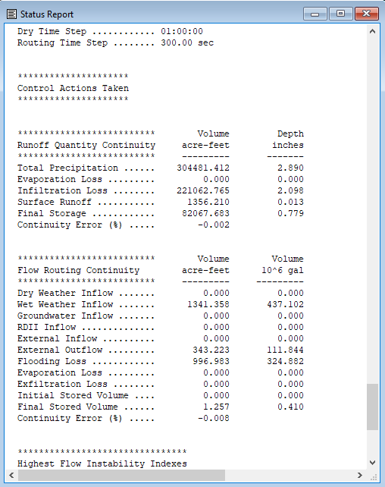
Figure 11: SWMM status report for the postdevelopment scenario simulation.
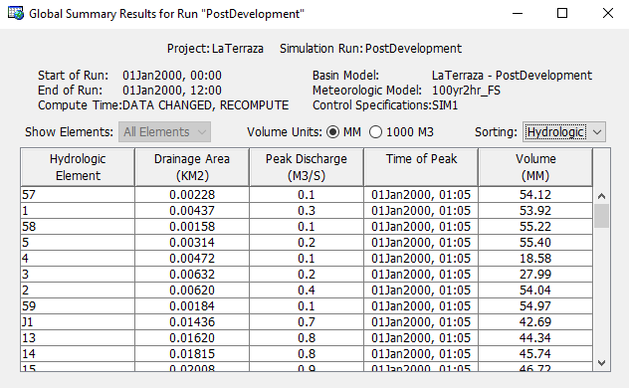
Figure 12: HEC-HMS global summary for the postdevelopment scenario.
Simulation results for runoff volume and peak flow from predevelopment and postdevelopment scenarios for all models at the watershed outlet are summarized in Table 1. Results from the AGWA Urban tool indicate a 14.2% increase in runoff for the postdevelopment scenario as compared to the predevelopment scenario. For HEC-HMS, the increase in runoff was 17.1%, whereas for SWMM the increase was 373%. The AGWA Urban tool seems to overpredict runoff volume when compared to the SWMM and HEC-HMS models. However, the peak flow for SWMM is the largest among the three results.
Model | Scenario | Runoff Volume (mm) | Peak Flow (m³/s)
AGWA Urban Tool | Predevelopment | 42.26 | 7.10
 | Postdevelopment | 52.83 | 7.33
EPA SWMM | Predevelopment | 8.67 | 0.89
 | Postdevelopment | 41.05 | 11.09
HEC-HMS | Predevelopment | 34.82 | 4.40
 | Postdevelopment | 40.71 | 5.00
Table 1: Summary of Runoff depth and Peak Flow at the watershed outlet for predevelopment and postdevelopment scenarios.
The dramatic increase and inconsistency of runoff in SWMM may be attributed to the different types of surface runoff calculations as compared to those in the AGWA Urban tool and HEC-HMS. The AGWA Urban tool and HEC-HMS assume that the street is part of the modeling element and surface runoff on both overland and streets, are calculated together using kinematic wave equations. Whereas, in SWMM the subcatchments and streets are modeled separately, where surface runoff for subcatchments is calculated using non-linear reservoir routing and manning’s equation, and for streets, runoff is calculated using kinematic wave equations. This difference in calculation methodology is also evident from the comparison of hydrographs for all models (Figure 13). The AGWA Urban tool registers the peak flow at 7.10 m³/s for predevelopment and 7.33 m³/s for postdevelopment scenarios. HEC-HMS simulates a lower peak flow of 4.40 m³/s for predevelopment and 5.00 m³/s for postdevelopment scenarios. However, both peaks occur at similar time steps in the simulation. In contrast, SWMM peak flows are at 0.89 m³/s for predevelopment and 11.1 m³/s for postdevelopment scenarios and do not attenuate like the AGWA Urban tool and HEC-HMS models. This may be due to junction nodes reaching capacity and delayed runoff release into the streets as street capacity decreases over time.
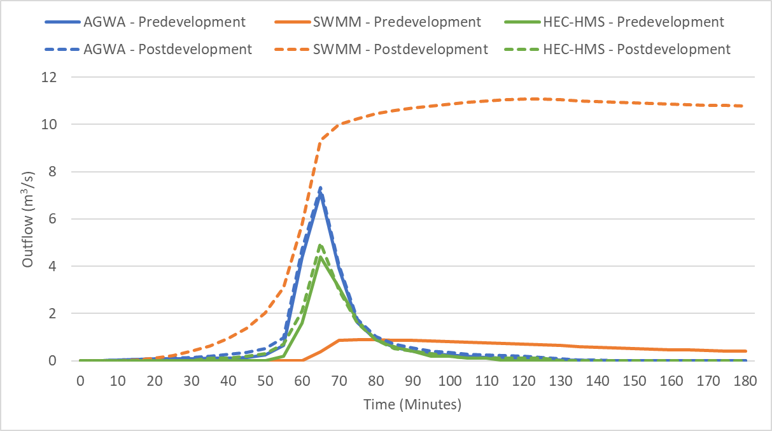
Figure 13: Comparison of hydrographs for predevelopment and postdevelopment scenarios for all models.
Similar results are observed by taking a closer look at the water balance for parcel ID 9, a representative parcel with similar dimensions and parameters to most of the parcels in the subdivision (Table 2). In this case, the effect of including streets within the modeling element for the AGWA Urban tool and HEC-HMS results in larger runoff as compared to SWMM for both scenarios. Due to the non-linear reservoir routing methodology in SWMM, infiltration volumes are registered higher than those in the AGWA Urban tool and HEC-HMS. At the lot level, without the inclusion of streets in the modeling element, SWMM did not compute any runoff for the predevelopment scenario. An argument can be made that the runoff volumes for the AGWA Urban tool and HEC-HMS for the predevelopment scenario may be due to the impervious streets in the modeling element. Further analysis is needed to validate this argument.
Model | Scenario | Precipitation (mm) | Infiltration (mm) | Runoff (mm) | Peak Flow (m³/s)
AGWA Urban Tool | Predevelopment | 73.41 | 21.63 | 49.73 | 0.44
 | Postdevelopment | 73.41 | 14.42 | 55.37 | 0.44
EPA SWMM | Predevelopment | 73.70 | 73.70 | 0 | 0
 | Postdevelopment | 73.70 | 48.19 | 0.255 | 0.30
HEC-HMS | Predevelopment | 73.41 | 25.74 | 49.50 | 0.40
 | Postdevelopment | 73.41 | 17.43 | 55.47 | 0.40
Table 2: Water balance comparison of Parcel ID 9 for predevelopment and postdevelopment scenarios.
Korgaonkar et al. (2018) validated the AGWA Urban tool for the La Terraza subdivision by comparing results with observed data for 47 precipitation events and was deemed a good fit without any calibration requirements. Based on the results of the validation, results from this case study can be used with some degree of confidence. However, it is recommended that both HEC-HMS and SWMM models be calibrated and/or validated using observed data to gain more confidence in their results. Additionally, in the case of SWMM, it may be necessary to represent the drainage network in more detail to ensure reliable flow routing.

Conclusion
The Regional Flood Control Districts in Arizona identified two hydrological models, namely, EPA SWMM and HEC-HMS as tools to estimate peak flows that enable drainage design for flood mitigation. The goal of this study was to compare these models with the AGWA Urban tool that is capable of small-scale hydrological modeling in urban environments and explore the potential of all three models to estimate urban enhanced runoff that can be used as a valuable groundwater recharge source. A qualitative comparison was undertaken to summarize the features and capabilities of the three software. Additionally, a case study was conducted to test the interface and simulation creation process of these models on a 66-parcel residential subdivision called La Terraza in Sierra Vista, Arizona. Predevelopment and postdevelopment scenarios were simulated in each model for a 100-year 2-hour precipitation event.
The AGWA Urban tool is available as a GIS-based add-in that requires a paid license to ESRI ArcMap software, a leading GIS software. It features an easy-to-use graphical user interface within the ArcMap software that takes advantage of readily available GIS data to model urban hydrology using the robust, physically based KINEROS2 model. The AGWA Urban tool can be used to model pre and post development scenarios, GI/LID practices such as retention basins, rain gardens, curb cuts, permeable driveways, and roof runoff harvesting. Each urban parcel can be represented as a modeling element with discrete implementation of pervious and impervious surfaces such as roofs, driveways, and yards within a parcel. At this scale, GI practices can be easily represented and modeled to measure performance and potential. Outputs from the AGWA Urban tool include peak flow and water balance volumes, including runoff, at the watershed and individual parcel scale. Some of the limitations of the AGWA Urban tool include the inability to model pressurized pipe flow, or back water, snowmelt, ground water interactions or water quality, and its reliance on the familiarity of using a GIS software, which may be a steep learning curve by itself.
SWMM is a standalone, open-source software that features a graphical user interface without GIS integration. SWMM is highly capable of modeling small-scale urban watersheds where subsurface drainage networks exist. It can model hydraulics such as open and closed conduit structures, pumps, and weirs in addition to evaporation of standing surface water and water quality. It can also model LID features such as bio-retention cells, rain gardens, green roofs, permeable pavements, infiltration trenches, rain barrels, roof disconnections and vegetative swales. SWMM provides several methodologies to model various hydrological processes and its outputs include flow rates, depths, and volumes for its modeling elements. However, SWMM has limitations in modeling large, non-urban watersheds as its overland flow routing is rudimentary due to the use of a non-linear reservoir to represent subcatchments. It is recommended that a different model be used to simulate overland flow and the output runoff can be fed into SWMM to model hydraulics, thereby using a coupled, hybrid approach for reliably modeling urban environments. Another drawback is the lack of functionality to bulk process input parameters within the user interface. However, the availability of editing input files using a text-editor served to be an asset in speeding up model creation.
HEC-HMS is a standalone software with a graphical user interface and limited GIS capabilities that is free to use. Built-in GIS capabilities can import a terrain model watershed delineation. Spatial datasets may also be imported and used to create subbasin elements. Certain parameters may be estimated by using grid data. HEC-HMS provides a tabular interface that can be used to edit parameters for all modeling elements. The HEC-HMS model provides several modeling options for hydrological processes; but is best suited for large scale watersheds to model subbasins and reaches. However, urban areas can be modeled with the help of the Kinematic Wave Transform method that represents pervious and impervious areas as two separate planes of a subbasin that contribute to a subcollector, collector or a channel representing gutters and conduits. HEC-HMS does not offer any representation of GI or LID practices in its software. However, reservoir modeling elements may be creatively used to represent certain GI practices. HEC-HMS outputs include runoff volumes, peak discharges and time-series results for individual modeling elements and the watershed.
All three software were successful in representing and modeling a 14-hectare residential subdivision for a 100-year 2-hour precipitation event in the case study. Predevelopment conditions were simulated by modifying certain land cover parameters to remove impervious areas in the watershed. By comparing predevelopment and postdevelopment simulation results, peak discharges and urban enhanced runoff were computed and compared. Without a validation or calibration exercise, simulation results had minor variations between the AGWA Urban tool and HEC-HMS.
The AGWA Urban tool, EPA SWMM and HEC-HMS are all capable of modeling urban areas at various scales to estimate peak discharges that can be used to design drainage practices for flood mitigation and to estimate urban enhanced runoff that can help in planning creative implementations, such green stormwater infrastructure or recharge facilities to manage stormwater runoff. The decision to choose a specific model may be influenced by several factors, such as the familiarity of the software, software licensing requirements, scale and level of detail, and the physical characteristics of the watershed including the need for hydraulic modeling, role of green infrastructure or low impact development and the size of the watersheds. As with any modeling approach, it is recommended that any model undergo a validation and/or calibration process that will instill confidence in the model results. In the absence of observed data for validation or calibration data, it is imperative that model assumptions and limitations are considered, and its viability is carefully assessed for use with the watershed of interest.

References
City of Tucson, Pima County. (2009) Stormwater Harvesting and Management as a Supplemental Water Source Technical Paper. Retrieved from http://webcms.pima.gov/UserFiles/Servers/Server_6/File/Government/Wastewater%20Reclamation/Water%20Resources/WISP/052109-Stormwater.pdf
Dietz, M. E. (2007). Low Impact Development Practices: A Review of Current Research and Recommendations for Future Directions. Water, Air, and Soil Pollution: 186(1-4): 351-363. http://dx.doi.org/10.1007/s11270-007-9484-z
Elliott, A. and Trowsdale, S. (2007). A Review of Models for Low Impact Urban Stormwater Drainage. Environmental Modelling and Software: 22(3): 394-405. http://dx.doi.org/10.1016/j.envsoft.2005.12.005
Forsee, W. J., & Ahmad, S. (2011). Evaluating urban storm-water infrastructure design in response to projected climate change. Journal of Hydrologic Engineering, 16(11), 865-873. https://doi.org/10.1061/(ASCE)HE.1943-5584.0000383
Goodrich, D. C., Burns, I. S., Unkrich, C. L., Semmens, D. J., Guertin, D. P., Hernandez, M., et al. (2012). KINERSO2/AGWA: Model Use, Calibration, and Validation. In Transactions of the American Society of Agricultural and Biological Engineers 55(4): 1561-1574. http://dx.doi.org/10.13031/2013.42264
Hopton, M., Simon, M., Borst, M., Garmestani, A., Jacobs, S., Lye, D., et al. (2015). Green Infrastructure for Stormwater Control: Gauging its Effectiveness with Community Partners. EPA/600/R-15/219. https://nepis.epa.gov/Exe/ZyPURL.cgi?Dockey=P100NE3S.txt
Kennedy, J. R. (2007). Changes in Storm Runoff with Urbanization: The Role of Pervious Areas in a Semiarid Environment. Master’s Thesis. Tucson, AZ: University of Arizona
Kennedy, J. R., Goodrich, D. C., and Unkrich, C. L. (2013). Using the KINEROS2 Modeling Framework to Evaluate the Increase in Storm Runoff from Residential Development in a Semiarid Environment. Journal of Hydrologic Engineering, 18(6): 698-706. http://dx.doi.org/10.1061/(ASCE)HE.1943-5584.0000655
Korgaonkar, Y., Guertin, D. P., Goodrich, D. C., Unkrich, C., Kepner, W., & Burns, I. S. (2018). Modeling Urban Hydrology and Green Infrastructure using the AGWA Urban Tool and the KINEROS2 Model. Frontiers in Built Environment, 4, 58. https://doi.org/10.3389/fbuil.2018.00058
Korgaonkar, Y., Guertin, D. P., Meixner, T., & Goodrich, D. C. (2021). Hydrological modeling of green infrastructure to quantify its effect on flood mitigation and water availability in the high school watershed in Tucson, AZ. ISPRS International Journal of Geo-Information, 10(7), 443. https://doi.org/10.3390/ijgi10070443
Miller, S. N., Semmens, D. J., Goodrich, D. C., Hernandez, M., Miller, R. C., Kepner, W. G., and Guertin, D. P. (2007). The Automated Geospatial Watershed Assessment Tool. Environmental Modelling & Software, 22(3): 365-377. http://dx.doi.org/10.1016/j.envsoft.2005.12.004
Natarajan, S., & Radhakrishnan, N. (2019). Simulation of extreme event-based rainfall–runoff process of an urban catchment area using HEC-HMS. Modeling Earth Systems and Environment, 5(4), 1867-1881. https://doi.org/10.1007/s40808-019-00644-5
Niazi, M., Nietch, C., Maghrebi, M., Jackson, N., Bennett, B. R., Tryby, M., & Massoudieh, A. (2017). Storm water management model: Performance review and gap analysis. Journal of Sustainable Water in the Built Environment, 3(2), 04017002. https://doi.org/10.1061/JSWBAY.0000817
Rosa, D. J., Clausen, J. C., & Dietz, M. E. (2015). Calibration and verification of SWMM for low impact development. JAWRA Journal of the American Water Resources Association, 51(3), 746-757. https://doi.org/10.1111/jawr.12272
Rossman, L. A. (2010). Storm water management model user's manual, version 5.0 (p. 276). Cincinnati: National Risk Management Research Laboratory, Office of Research and Development, US Environmental Protection Agency.
Sahu, M., Shwetha, H., & Dwarakish, G. (2023). State-of-the-art hydrological models and application of the HEC-HMS model: A review. Modeling Earth Systems and Environment, Modeling earth systems and environment, 2023. https://doi.org/10.1007/s40808-023-01704-7
Shuster, W. D., Bonta, J., Thurston, H., Warnemuende, E., and Smith, D. R. (2005). Impacts of Impervious Surface on Watershed Hydrology: A Review. Urban Water Journal, 2(4): 263-275. http://dx.doi.org/10.1080/15730620500386529
Smith, R. E., and D. C. Goodrich. 2000. Model for rainfall excess patterns on randomly heterogeneous areas. J. Hydrol. Eng. 5(4): 355-362. https://ascelibrary.org/doi/10.1061/(ASCE)1084-0699(2000)5%3A4(355)
Smith, R. E., Goodrich, D. C., Woolhiser, D. A., and Unkrich, C. L. (1995). KINEROS - A Kinematic Runoff and Erosion Model. Computer Models of Watershed Hydrology, 20: 627-668
Zoppou, C. (2001). Review of urban storm water models. Environmental Modelling & Software, 16(3), 195-231. https://doi.org/10.1016/S1364-8152(00)00084-0

